Lab-Level 2

1.Display information for System Activity, Hardware and System Information.
- Monitoring tools provide metrics that can be used to get information about system activities. Monitoring the system allows you to trace the root of causes hampering the systems performance
- comman:-vmstat 3
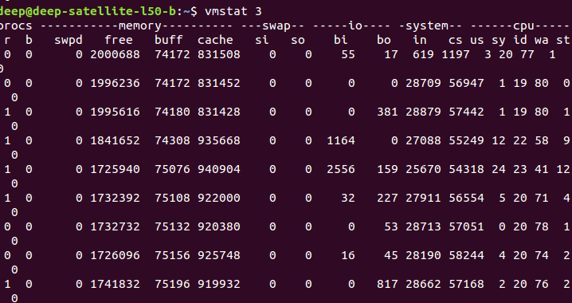

2.Get Information About Active / Inactive Memory Pages.
- Command:-/proc/meminfo
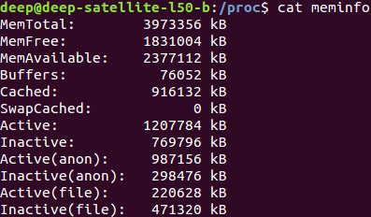

3.Find Out The Top 10 Memory Consuming Process (Implement using commands).
- Command:-free -m
- command:-top
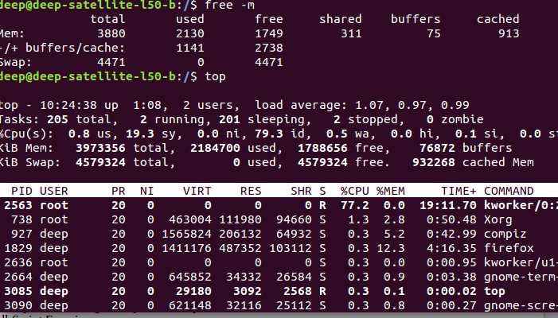
4.Display activities for each available processor.
- Command:-mpstat -P ALL
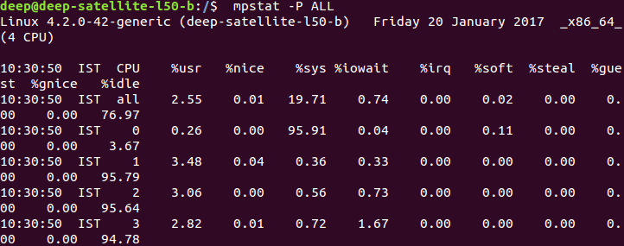

5.Display process memory usage. Also check for particular pid.
- Command:-ps aux --sort -pid
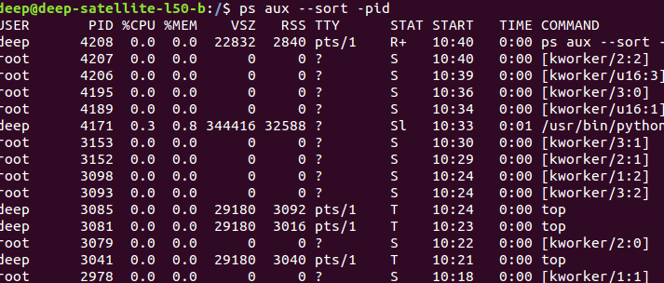

6.How to prevent ssh login? Implement, explain & how it works.
- To disable root login, open the main ssh configuration file /etc/ssh/sshd_config with your choice of editor.
- Search for the following line in the file.


- Remove the ‘#‘ from the beginning of the line. Make the line look like similar to this.
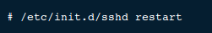

- Next, we need to restart the SSH daemon service.

- Now try to login with root user, you will get “Access Denied” error.
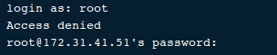

Shell Script Exercise
1.How to write shell script that will add two numbers, which are supplied as command line argument, and if these two numbers are not given show error and its usage.
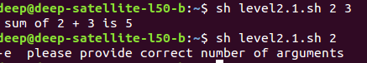

2.Write Script to find out biggest number from given three numbers. Numbers are supplies as command ine argument. Print error if sufficient arguments are not supplied.
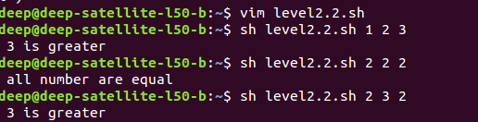

3.Write a simple shell script that takes any number of arguments on the command line, and prints the arguments with “Hello ” in front.
e.g. If the name of the script is “hello”, then you should be able to run it like this:
$ hello Nick Urbanik
Hello Nick Urbanik
$ hello Edmund
Hello Edmund
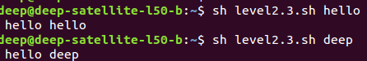

4.Write script to print numbers as 5,4,3,2,1 using while loop.
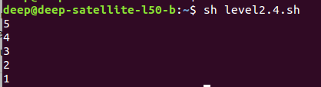

5.Write a simple shell script that takes two numbers as parameters and uses a while loop to print all the numbers from the first to the second inclusive, each number separated only by a space from the previous number.
e.g. If the script is called “jot”, then
$ jot 2 8
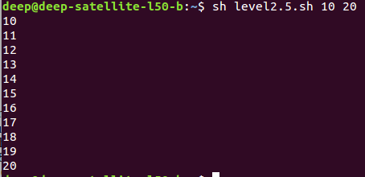
2 3 4 5 6 7 8

6.Write Script, using case statement to perform basic math operation as follows
+ addition
- subtraction
x multiplication
/ division
The name of script must be 'q4' which works as follows
$ ./q4 20 / 3, Also check for sufficient command line arguments
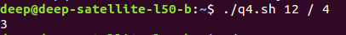

7.Write Script to see current date, time, username, and current directory
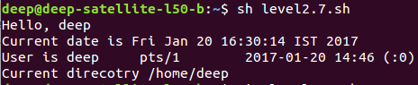

8.Write a script which displays “Good morning”, “Good afternoon” or “Good evening”, on the monitor, depending on the time of running the script.
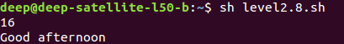

9.Write a script which reads a number in units of seconds and converts it to the units
hours:minutes:seconds and prints the result to standard output. Your script must prompt for re-input if a negative value is input.
e.g. Enter number of seconds: 12345
Result: 12345 seconds in hours:minutes:seconds is 3:25:45

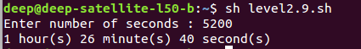

10.Write script to print given number in reverse order, for eg. If no is 123 it must print as 321.
Write script to print given numbers sum of all digit, eg. If no is 123 it's sum of all digit will be 1+2+3 =
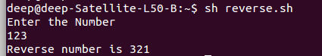

11.Write script to print given numbers sum of all digit, eg. If no is 123 it's sum of all digit will
be 1+2+3 =6.
Program:
echo Enter the Number
read a
b=0
c=0
while [ $a -gt 0 ]
do
b=`expr $a % 10`
c=`expr $c + $b`
a=`expr $a / 10`
done
echo "Addition of number is $c "

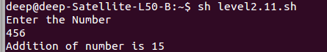

12.Write script to determine whether given file exist or not, file name is supplied as command line argument, also check for sufficient number of command line argument
Program:
if [ $# -ne 1 ]
a=$1
then
echo "Usage - $0 file-name"
fi

if [ -f $a ]
then
echo "$a exist"
else
echo "$a does not exist"
fi

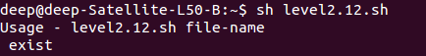

13.Write script to determine whether given command line argument ($1) contains "*" symbol or not, if $1 does not contains "*" symbol add it to $1, otherwise show message "Symbol is not required".
e.g. If we called this script Q12 then after giving ,
$ Q12 /bin
Here $1 is /bin, it should check whether "*" symbol is present or not if not it should print Required i.e. /bin/*, and if symbol present then Symbol is not required must be printed. Test your script as
$ Q12 /bin
$ Q12 /bin/*
Program:
cat "$1" > /tmp/file.$$ 2>/tmp/file0.$$

grep "*" /tmp/file.$$ >/tmp/file0.$$

if [ $? -eq 1 ]
then
echo "Symbol Required"
else
echo "Symbol Not required"
fi

rm -f /tmp/file.$$
rm -f /tmp/file0.$$

14.Write script to print contains of file from given line number to next given number of lines.
e.g. If we called this script as Q13 and run as
$ Q13 5 5 myf ,
Here print contains of 'myf' file from line number 5 to next 5 line of that file.
Program:
if [ $# -ne 3 ]
then
echo "Please enter valid input"
else
a=$1
b=$2
c=`expr $1 + $2`
cat $3|head -$c|tail -$b
fi
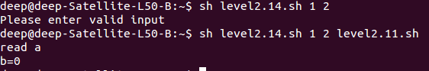

15.Write script to implement getopts statement, your script should understand following command line argument called this script Q14,
Q14 -c -d -m -e
Where options work as
-c clear the screen
-d show list of files in current working directory
-m start mc (midnight commander shell) , if installed
-e { editor } start this { editor } if installed
Program:
if [ $# -eq 0 ]
then
echo "Please enter valid argument"
fi
a=$1
case $a in
-c)
clear
echo "$a cleared screen";;
-d)
ls
echo "$a displays list of files";;
-m)
mc
echo "$a midnight commander shwll";;
-e)
gedit
echo "$a gedit screen";;
*)
echo "invalid input";;
esac

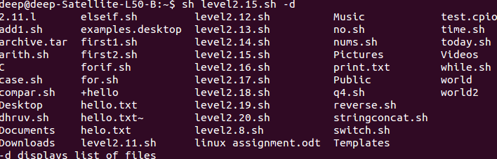

16.Write script called say Hello, put this script into your startup file called .bash_profile, the script should run as soon as you logon to system, and it print any one of the following message in infobox using dialog utility, if installed in your system, If dialog utility is not installed then use echo statement to print message
Good Morning
Good Afternoon
Good Evening , according to system time.
Program:
a=`date +"%H"`
if [ $a -ge 6 -a $a -le 12 ]
then
b="Good Morning"
elif [ $a -ge 12 -a $a -le 17 ]
then
b="Good Afternoon"
elif [ $a -ge 17 -a $a -le 20 ]
then
b="Good Evening"
else
b="Good Night"
fi
dialog --title "Greeting" --msgbox "$b" 5 20

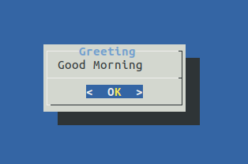

17.How to write script, that will print, Message "Hello World" , in Bold and Blink effect, and in different colors like red, brown etc using echo command.
Program:
clear
echo "\033[1m Hello World"
echo "\033[0m Hello World"
echo "\033[31m Hello World"
echo "\033[32m Hello World"
echo "\033[33m Hello World"
echo "\033[34m Hello World"
echo "\033[35m Hello World"
echo "\033[36m Hello World"
echo "\033[0m Hello World"
echo "\033[41m Hello World"
echo "\033[42m Hello World"
echo "\033[43m Hello World"
echo "\033[44m Hello World"
echo "\033[45m Hello World"
echo "\033[46m Hello World"
echo "\033[0m Hello World"
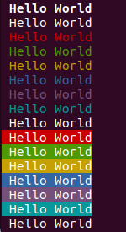

18.Write script to implement background process that will continually print current time in upper right corner of the screen, while user can do his/her normal job at $ prompt.
Program:
clear
while [ 1 ]
do
a=`date +"%r"`
tput cup 0 60; $a
done
#echo $a

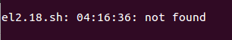

19.Write shell script to convert file names from UPPERCASE to lowercase file names or vice versa.

a=$1
case $a in

[A-Z]*)

b=`echo $a | tr '[:upper:]' '[:lower:]'`;;

[a-z]*)

b=`echo $a | tr '[:lower:]' '[:upper:]'`;;

esac
cat $a>$b
rm $a

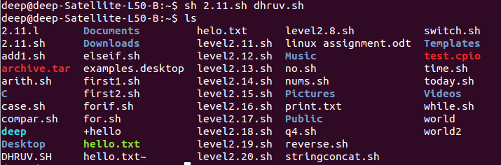
20.Write shell script to show various system configuration like
1) Currently logged user and his logname
2) Your current shell
3) Your home directory
4) Your operating system type
5) Your current path setting
6) Your current working directory
7) Show Currently logged number of users
8) About your os and version ,release number , kernel version
9) Show all available shells
10) Show mouse settings
11) Show computer cpu information like processor type, speed etc
12) Show memory information
13) Show hard disk information like size of hard-disk, cache memory, model etc
14) File system (Mounted)
User name is deep
clear
echo "User name is $USER"
echo "Logname is $LOGNAME"
echo "Current Shell is $SHELL"
echo "Home Directory is $HOME"
echo "Operating System `uname -o`"
echo "Current Path $PATH"
echo "Current Directory `pwd`"
echo "Current Logged Users $nouser"
echo "About OS Version `uname -a`"
echo "Model: `cat /proc/ide/hda/model` "
echo "available shells are: `cat /etc/shells`"
echo "`xinput --list --short`"
echo "CPU information are: `cat /proc/cpuinfo`"
echo "Memeory information are:`cat /proc/meminfo`"
echo "hard disk information: `lscpu`"
echo "file system mounted `df -T`"

o/p:-
Logname is deep
Current Shell is /bin/bash
Home Directory is /home/deep
Operating System GNU/Linux
Current Path /usr/local/sbin:/usr/local/bin:/usr/sbin:/usr/bin:/sbin:/bin:/usr/games:/usr/local/games
Current Directory /home/deep
Current Logged Users
About OS Version Linux deep-Satellite-L50-B 3.16.0-23-generic #31-Ubuntu SMP Tue Oct 21 17:56:17 UTC 2014 x86_64 x86_64 x86_64 GNU/Linux
cat: /proc/ide/hda/model: No such file or directory
Model:
available shells are: # /etc/shells: valid login shells
/bin/sh
/bin/dash
/bin/bash
/bin/rbash
⎡ Virtual core pointer id=2 [master pointer (3)]
⎜ ↳ Virtual core XTEST pointer id=4 [slave pointer (2)]
⎜ ↳ SynPS/2 Synaptics TouchPad id=14 [slave pointer (2)]
⎜ ↳ SIGMACHIP USB Keyboard id=10 [slave pointer (2)]
⎣ Virtual core keyboard id=3 [master keyboard (2)]
↳ Virtual core XTEST keyboard id=5 [slave keyboard (3)]
↳ Power Button id=6 [slave keyboard (3)]
↳ Video Bus id=7 [slave keyboard (3)]
↳ Power Button id=8 [slave keyboard (3)]
↳ TOSHIBA Web Camera - HD id=12 [slave keyboard (3)]
↳ AT Translated Set 2 keyboard id=13 [slave keyboard (3)]
↳ Toshiba input device id=15 [slave keyboard (3)]
↳ SIGMACHIP USB Keyboard id=9 [slave keyboard (3)]
CPU information are: processor : 0
vendor_id : GenuineIntel
cpu family : 6
model : 69
model name : Intel(R) Core(TM) i5-4200U CPU @ 1.60GHz
stepping : 1
microcode : 0x17
cpu MHz : 2599.179
cache size : 3072 KB
physical id : 0
siblings : 4
core id : 0
cpu cores : 2
apicid : 0
initial apicid : 0
fpu : yes
fpu_exception : yes
cpuid level : 13
wp : yes
flags : fpu vme de pse tsc msr pae mce cx8 apic sep mtrr pge mca cmov pat pse36 clflush dts acpi mmx fxsr sse sse2 ss ht tm pbe syscall nx pdpe1gb rdtscp lm constant_tsc arch_perfmon pebs bts rep_good nopl xtopology nonstop_tsc aperfmperf eagerfpu pni pclmulqdq dtes64 monitor ds_cpl vmx est tm2 ssse3 fma cx16 xtpr pdcm pcid sse4_1 sse4_2 movbe popcnt tsc_deadline_timer aes xsave avx f16c rdrand lahf_lm abm ida arat epb xsaveopt pln pts dtherm tpr_shadow vnmi flexpriority ept vpid fsgsbase tsc_adjust bmi1 avx2 smep bmi2 erms invpcid
bogomips : 4589.06
clflush size : 64
cache_alignment : 64
address sizes : 39 bits physical, 48 bits virtual
power management:

processor : 1
vendor_id : GenuineIntel
cpu family : 6
model : 69
model name : Intel(R) Core(TM) i5-4200U CPU @ 1.60GHz
stepping : 1
microcode : 0x17
cpu MHz : 2484.988
cache size : 3072 KB
physical id : 0
siblings : 4
core id : 0
cpu cores : 2
apicid : 1
initial apicid : 1
fpu : yes
fpu_exception : yes
cpuid level : 13
wp : yes
flags : fpu vme de pse tsc msr pae mce cx8 apic sep mtrr pge mca cmov pat pse36 clflush dts acpi mmx fxsr sse sse2 ss ht tm pbe syscall nx pdpe1gb rdtscp lm constant_tsc arch_perfmon pebs bts rep_good nopl xtopology nonstop_tsc aperfmperf eagerfpu pni pclmulqdq dtes64 monitor ds_cpl vmx est tm2 ssse3 fma cx16 xtpr pdcm pcid sse4_1 sse4_2 movbe popcnt tsc_deadline_timer aes xsave avx f16c rdrand lahf_lm abm ida arat epb xsaveopt pln pts dtherm tpr_shadow vnmi flexpriority ept vpid fsgsbase tsc_adjust bmi1 avx2 smep bmi2 erms invpcid
bogomips : 4589.06
clflush size : 64
cache_alignment : 64
address sizes : 39 bits physical, 48 bits virtual
power management:

processor : 2
vendor_id : GenuineIntel
cpu family : 6
model : 69
model name : Intel(R) Core(TM) i5-4200U CPU @ 1.60GHz
stepping : 1
microcode : 0x17
cpu MHz : 2300.000
cache size : 3072 KB
physical id : 0
siblings : 4
core id : 1
cpu cores : 2
apicid : 2
initial apicid : 2
fpu : yes
fpu_exception : yes
cpuid level : 13
wp : yes
flags : fpu vme de pse tsc msr pae mce cx8 apic sep mtrr pge mca cmov pat pse36 clflush dts acpi mmx fxsr sse sse2 ss ht tm pbe syscall nx pdpe1gb rdtscp lm constant_tsc arch_perfmon pebs bts rep_good nopl xtopology nonstop_tsc aperfmperf eagerfpu pni pclmulqdq dtes64 monitor ds_cpl vmx est tm2 ssse3 fma cx16 xtpr pdcm pcid sse4_1 sse4_2 movbe popcnt tsc_deadline_timer aes xsave avx f16c rdrand lahf_lm abm ida arat epb xsaveopt pln pts dtherm tpr_shadow vnmi flexpriority ept vpid fsgsbase tsc_adjust bmi1 avx2 smep bmi2 erms invpcid
bogomips : 4589.06
clflush size : 64
cache_alignment : 64
address sizes : 39 bits physical, 48 bits virtual
power management:

processor : 3
vendor_id : GenuineIntel
cpu family : 6
model : 69
model name : Intel(R) Core(TM) i5-4200U CPU @ 1.60GHz
stepping : 1
microcode : 0x17
cpu MHz : 2300.089
cache size : 3072 KB
physical id : 0
siblings : 4
core id : 1
cpu cores : 2
apicid : 3
initial apicid : 3
fpu : yes
fpu_exception : yes
cpuid level : 13
wp : yes
flags : fpu vme de pse tsc msr pae mce cx8 apic sep mtrr pge mca cmov pat pse36 clflush dts acpi mmx fxsr sse sse2 ss ht tm pbe syscall nx pdpe1gb rdtscp lm constant_tsc arch_perfmon pebs bts rep_good nopl xtopology nonstop_tsc aperfmperf eagerfpu pni pclmulqdq dtes64 monitor ds_cpl vmx est tm2 ssse3 fma cx16 xtpr pdcm pcid sse4_1 sse4_2 movbe popcnt tsc_deadline_timer aes xsave avx f16c rdrand lahf_lm abm ida arat epb xsaveopt pln pts dtherm tpr_shadow vnmi flexpriority ept vpid fsgsbase tsc_adjust bmi1 avx2 smep bmi2 erms invpcid
bogomips : 4589.06
clflush size : 64
cache_alignment : 64
address sizes : 39 bits physical, 48 bits virtual
power management:
Memeory information are:MemTotal: 3969968 kB
MemFree: 1518588 kB
MemAvailable: 2120868 kB
Buffers: 86448 kB
Cached: 1052552 kB
SwapCached: 0 kB
Active: 1506364 kB
Inactive: 754680 kB
Active(anon): 1124784 kB
Inactive(anon): 393244 kB
Active(file): 381580 kB
Inactive(file): 361436 kB
Unevictable: 32 kB
Mlocked: 32 kB
SwapTotal: 4579324 kB
SwapFree: 4579324 kB
Dirty: 4 kB
Writeback: 0 kB
AnonPages: 1122084 kB
Mapped: 391236 kB
Shmem: 395976 kB
Slab: 91540 kB
SReclaimable: 56416 kB
SUnreclaim: 35124 kB
KernelStack: 7632 kB
PageTables: 30772 kB
NFS_Unstable: 0 kB
Bounce: 0 kB
WritebackTmp: 0 kB
CommitLimit: 6564308 kB
Committed_AS: 4388348 kB
VmallocTotal: 34359738367 kB
VmallocUsed: 546520 kB
VmallocChunk: 34359114228 kB
HardwareCorrupted: 0 kB
AnonHugePages: 432128 kB
HugePages_Total: 0
HugePages_Free: 0
HugePages_Rsvd: 0
HugePages_Surp: 0
Hugepagesize: 2048 kB
DirectMap4k: 72448 kB
DirectMap2M: 2996224 kB
DirectMap1G: 1048576 kB
hard disk information: Architecture: x86_64
CPU op-mode(s): 32-bit, 64-bit
Byte Order: Little Endian
CPU(s): 4
On-line CPU(s) list: 0-3
Thread(s) per core: 2
Core(s) per socket: 2
Socket(s): 1
NUMA node(s): 1
Vendor ID: GenuineIntel
CPU family: 6
Model: 69
Model name: Intel(R) Core(TM) i5-4200U CPU @ 1.60GHz
Stepping: 1
CPU MHz: 2300.089
CPU max MHz: 2600.0000
CPU min MHz: 800.0000
BogoMIPS: 4589.06
Virtualization: VT-x
L1d cache: 32K
L1i cache: 32K
L2 cache: 256K
L3 cache: 3072K
NUMA node0 CPU(s): 0-3
file system mounted Filesystem Type 1K-blocks Used Available Use% Mounted on
/dev/sda8 ext4 19573428 3530316 15025768 20% /
none tmpfs 4 0 4 0% /sys/fs/cgroup
udev devtmpfs 1973872 4 1973868 1% /dev
tmpfs tmpfs 397000 1304 395696 1% /run
none tmpfs 5120 4 5116 1% /run/lock
none tmpfs 1984984 356 1984628 1% /run/shm
none tmpfs 102400 80 102320 1% /run/user
/dev/sda7 fuseblk 212278972 37259372 175019600 18% /mnt/3214C5A614C56D83
/dev/sda2 vfat 98304 53301 45003 55% /boot/efi
/dev/sdb1 vfat 15416296 1624 15414672 1% /media/deep/UBUNTU 14_1

